|  |  |  |  |
| --- | --- | --- | --- |
| Gears | Driven by | Drives | On the same shaft as |
| 12T spur gear | The motor | 36T spur gear | - |
| 36T spur gear | 12T spur gear | - | 24T bevel gear |
| 24T bevel gear | - | 24T bevel gear | 36T spur gear |
| 24T bevel gear | 24T bevel gear | - | 12T spur gear |
| 12T spur gear | - | 36T spur gear | 24T bevel gear |
| 36T spur gear | 12T spur gear | - | 24T spur gear |
| 24T spur gear | - | 48T spur gear | 36T spur gear |
| 48T spur gear | 24T spur gear | - | - |

|  |  |
| --- | --- |
|  | Meshing gears |
| Mesh 1 | 12T spur gear with 36T spur gear |
| Mesh 2 | 24T bevel gear with 24T bevel gear |
| Mesh 3 | 12T spur gear with 36T spur gear |
| Mesh 4 | 24T spur gear with 48T spur gear |

|  |  |  |
| --- | --- | --- |
|  | Peak condition | Actual condition |
| Current [A] | 2.936 | 1.847 |
| Output speed [rad/s] | 11.367 | 14.537 |
| Output torque [Nm] | 1.211 | 0.941 |
| Trip time [s] | 3.091 | 15.948 |

|  |  |  |  |  |  |  |
| --- | --- | --- | --- | --- | --- | --- |
|  | Maximum Torque [Nm] | Experienced  Torque [Nm] | Maximum tangential force [N] | Experienced tangential force [N] | Experienced radial force [N] | Rotational speed [rad/s] |
| Gear 1 [12T] | 3 | 0.941 | 450 | 148.228 | 53.95 | 14.537 |
| Gear 2 [36T] | 3.4 | 2.627 | 700 | 137.879 | 50.184 | 4.508 |
| Gear 3 [24T] | 3 | 2.627 | 300 | 206.819 | 75.276 | 4.508 |
| Gear 4 [24T] | 3 | 2.489 | 300 | 195.99 | 71.335 | 4.272 |
| Gear 5 [12T] | 3 | 2.489 | 450 | 391.98 | 142.669 | 4.272 |
| Gear 6 [36T] | 3.4 | 6.946 | 700 | 364 | 132.709 | 1.324 |
| Gear 7 [24T] | 1 | 6.946 | 580 | 546.923 | 199.064 | 1.324 |
| Gear 8 [48T] | 1.2 | 13.269 | 580 | 522.417 | 190.144 | 0.638 |
| Gear 9 [48T] | 1.2 | 12.922 | 580 | 508.74 | 185.166 | 0.621 |

|  |  |  |  |  |  |  |  |  |  |
| --- | --- | --- | --- | --- | --- | --- | --- | --- | --- |
|  | D at gear 1 | D at gear 2 | D at gear 3 | D at gear 4 | D at gear 5 | D at gear 6 | D at gear7 | D at gear 8 | D at gear 9 |
| Shaft 1 |  |  |  |  |  |  |  |  |  |
| Shaft 2 |  |  |  |  |  |  |  |  |  |
| Shaft 3 |  |  |  |  |  |  |  |  |  |
| Shaft 4 |  |  |  |  |  |  |  |  |  |
| Shaft 5 |  |  |  |  |  |  |  |  |  |
| Shaft 6 |  |  |  |  |  |  |  |  |  |
| Shaft 7 |  |  |  |  |  |  |  |  |  |
| Shaft 8 |  |  |  |  |  |  |  |  |  |
| Shaft 9 |  |  |  |  |  |  |  |  |  |

|  |  |  |  |
| --- | --- | --- | --- |
|  | Maximum torque [Nm] | Experienced torque [Nm] | Plate thickness needed [mm] |
| Gear 6 [36T] | 3.4 | 6.946 | 0.958 |
| Gear 7 [24T] | 1 | 6.946 | 0.958 |
| Gear 8 [48T] | 1.2 | 13.269 | 1.659 |
| Gear 9 [48T] | 1.2 | 12.922 | 1.615 |

Radial force

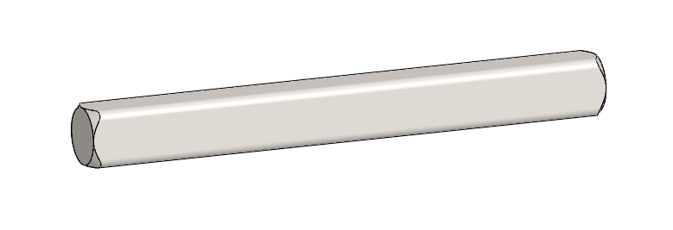

Tangential force

Shaft 2

Shaft 3

Shaft 2

Shaft 4

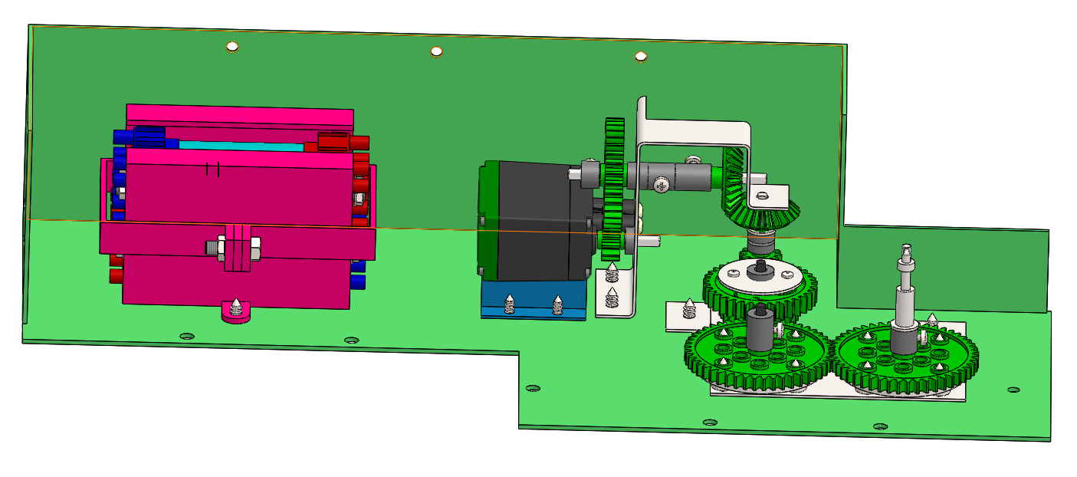

Shaft 6

Shaft 5

Shaft 1

H

|  |  |  |  |  |
| --- | --- | --- | --- | --- |
|  | Bought parts | 3D printed parts | Sheet metal parts | Machined parts |
| Total mass [kg] | 0.607 | 0.469 | 0.341 | 0.03 |
| Total cost [Rands] | 694.1 | 978.656 | 178.241 | 975.765 |

|  |  |  |
| --- | --- | --- |
| Development costs | R140 000 |  |
| Ramp-up costs | R446 400 |  |
| Volume production cost per product | R892.53 |  |
| Sales price to distributor per product | R1 400 |  |
| Steady state production / sales per month | 260 |  |